# Notes on paper: “Fast nonlinear gravity inversion in spherical coordinates with application to the South American Moho”

Introduction:

* Two main geophysical methods to estimate moho are seismology and gravimetry (satellites like GRACE and GOCE)
* Estimating moho depth from gravity data is a nonlinear inverse problem, more data in urban regions compared to vast areas of forest, mountains etc.
* Bott (1960) proposed a method based on iteratively applying corrections to a starting estimate based on the inversion residuals.
* Spherical Earth approximation is preferred when estimating Moho depth from gravity data. Reguzzoni (2013) used a spherical Earth approximation to estimate the global Moho relief using data from the GOCE satelites.
* Another method is non-spectral gravity inversion methods- using a set of juxtaposed right-rectangular prisms to approximate depth to basement in sedimentary basins. Use of prisms implies planar Earth approximation and may not be adequate for depth to moho on a large-scale study. A way round this is to use tesseroids (spherical prisms)- need to then solve the forward problem numerically.
* Two hyperparameters control inversion results- density and reference level (constant depth of the normal Earth Moho. Two most used methods for estimating the regularization parameter are the L-curve criterion and Generalized Cross Validation.
* The stability of the inversion is achieved through smoothness regularization. Employ variant of GCV known as hold-out cross-validation to estimate regularization parameter. Also estimate the density contrast and reference level simultaneously in a second validation step using the knowledge of the Moho depth at a few points.

Methodology:

* 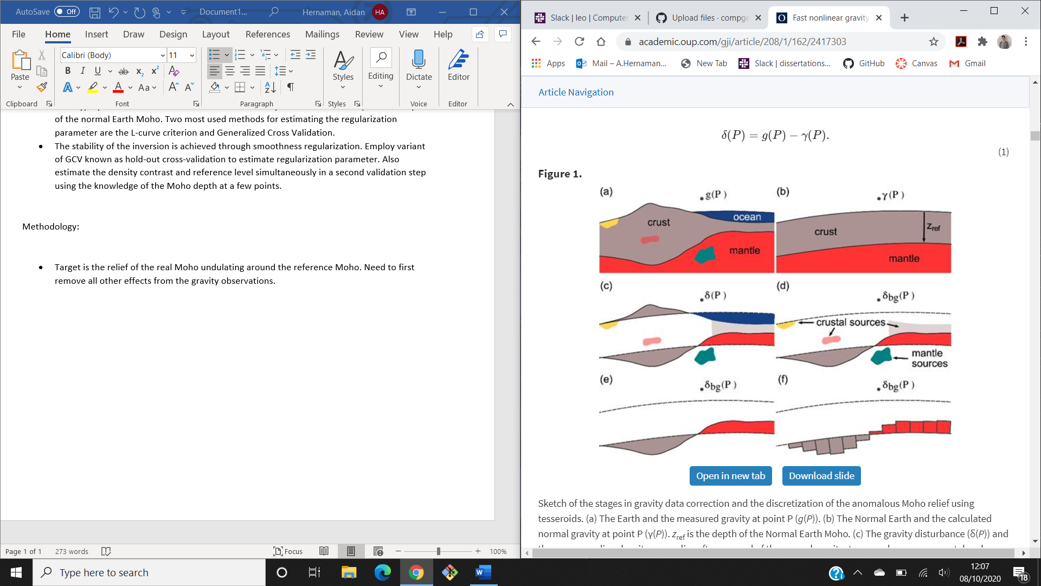Target is the relief of the real Moho undulating around the reference Moho. Need to first remove all other effects from the gravity observations. Difference between the observed gravity at point P(g(P)) and Normal gravity at the same point is know as the gravity disturbance. Only contains gravitational effects of density distributions that are anomalous with respect to the Normal Earth, Includes all masses above the surface of the ellipsoid (topography), the mass deficiency of the oceans, mass deficiency of sedimentary basins, crustal sources (e.g. igneous intrusions, lateral density changes, etc.).
* To estimate Moho relief all other gravitational effects must be removed or minimalized- from this obtain full Bouguer disturbance. The gravitational attraction of the topography, oceans and basins are calculated in a spherical Earth approximation by forward modelling using tesseroids.
* Ask Leo to go over mathematics in 2.2 Inverse Problem and 2.3 Regularization
* Propose a regularized version of Bott’s method to invert gravity for estimating Moho depth in spherical coordinates. To adapt to spherical coordinates tesseroids forward modelling is used to achieve accurate results. Formulation maintains the regularized solution for the Gauss-Newton method but replaces the full Jacobian matrix with the Bouguer plate approximation.
* The main advantage of our formulation is that is retains efficiency of Bott’s method while stabilizing the solution through the Tikhonov regularization.
* Parameters that influence the inversion result but are not estimated directly in the inversion are known as hyperparameters. In this case they are the regularization parameter (mew), the Moho density-contrast, and the depth of the Normal Earth Moho. To estimate these parameters, assume fixed values for Normal Moho and density-contrast and perform hold-out cross-validation procedure to estimate optimal value for regularization parameter. Used regularization parameter to validate Normal Moho and density contrast to get the hyperparameters.
* Regularization parameter controls how much smoothness is applied to the inversion result. Optimal value will stabilize and smooth the solution whilst not compromising the fit to data. Two widely used methods are L-curve criterion and cross validation.
* Use Hold-out cross-validation which consists of splitting the observed data set into two independent parts- a training set and testing set.
* Use Seismologic studies (receiver functions, surface wave dispersion, deep refraction experiments) to determine optimal values of Normal Moho and density-contrast.

Application to synthetic data:

* Test and illustrate proposed inversion method by applying it to two noise-corrupted synthetic data sets. First one is generated by a simple Moho model simulating the transition from a thicker continental crust to a thinner oceanic crust. Uses cross-validation to estimate hyperparameters, this test is simplified to investigate the efficiency of the inversion.
* Second data set is generated by a more complex model derived from the South American portion of the global CRUST1.0 model validation procedure using synthetic seismological data to estimate hyperparameters, this is meant to simulate more realistic data.
* Most time spent on inversion is on the Tesseroid forward modelling.
* Smooth recovered model indicating that the cross-validation procedure was effective in estimating an optimal regularization parameter.
* In general, large residuals are associated with sharp increases in Moho depth.

Application to the South American Moho:

* Follow the application of van der Meijde (2013) but with some differences, mainly using a different data set and performing all modelling in spherical coordinates using tesseroids. Data is corrected of the effects of topography and sedimentary basins. Crust and mantle heterogeneities cannot be properly accounted for in regions of sparse information coverage.
* In general, larger gravity residuals appear to be associated with sharp variations in the estimated Moho depth.
* Differences between Moho depth model and seismological data may indicate regions where initial assumptions are inadequate or where have failed to correct for all crustal and mantle sources. Largest differences are seen along the Andean Province and are likely caused by the fact that our model does not include subducting Nazca plate.